DONATION REQUEST

**BENNETT FIRE DEPARTMENT**

The volunteers of the Bennett Wisconsin Volunteer Fire Department and First Responders are holding their 43rd Annual Flea Market and Auction on June 28th, 2024.

We are accepting any donations to be used as door prizes and gifts from local businesses and individuals. We will display your business name or business card to advertise your donation. All proceeds from this event will go toward new equipment for our fire and emergency systems.

The Bennett Volunteers graciously thank you in advance for your donation.

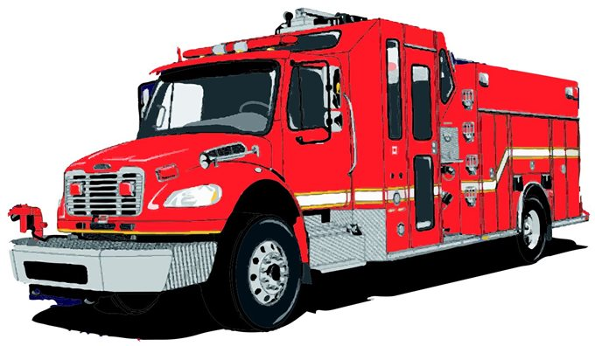

Sincerely,

*David Dittbrender*

President

FRIENDS of Bennett Fire Depart.

**Please contact Morgan when**

**donations are ready for pickup. 920-471-5433/morg0306@gmail.com**